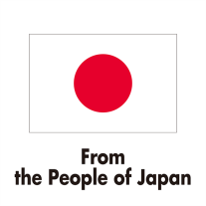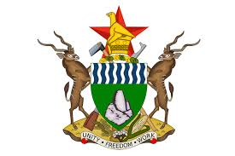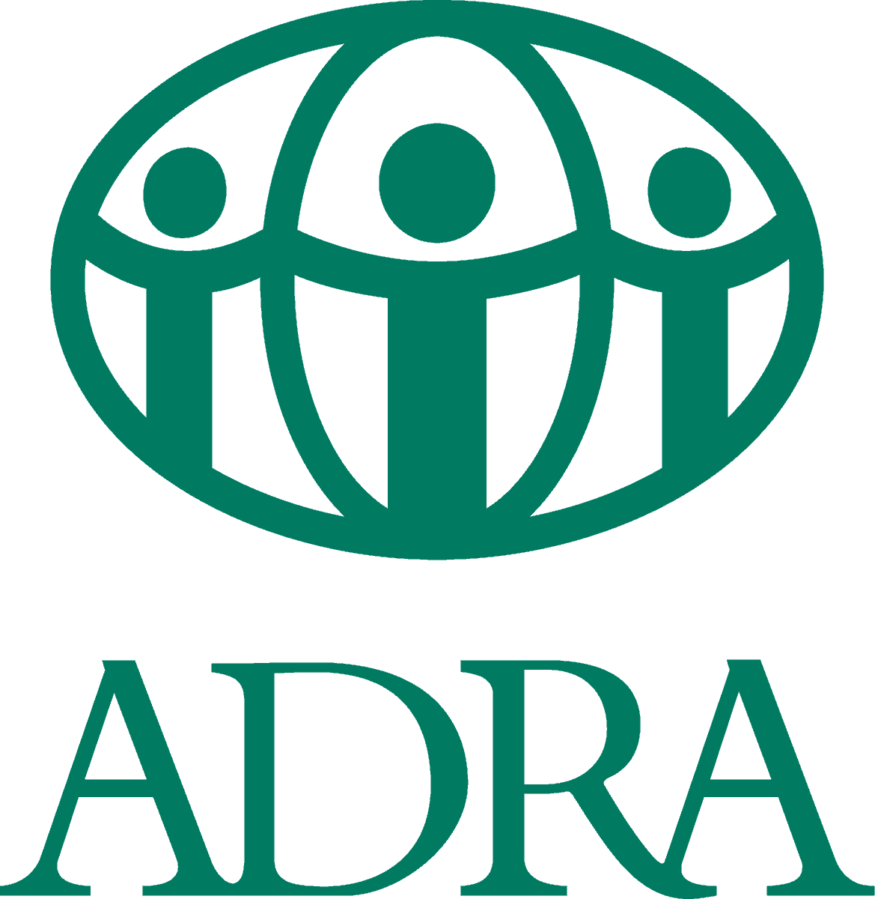

**Handover of Japan-Funded Education Project in Gokwe North District**

On 23 June, the handover ceremony of the Comprehensive Education Project funded by the Government of Japan was held at Chirisa Primary School in Gokwe North District.

The three-year project, funded with US$ 2.3 million, has improved the educational environment at three primary schools, such as with new classroom blocks, staff houses and administration blocks, benefitting around 1,900 students, 40 teachers and 5,400 community members. The project was jointly implemented by ADRA Japan and [ADRA Zimbabwe](https://www.facebook.com/ADRAZim/?__cft__%5b0%5d=AZVv7Nj7w53U3nOVW6Mzp0-z-Naf0qyYybdziWFLSIXnp9kPWHIcNrtwtl5OBgFhS1cGVtw0shdYl_uPjNkjSeq70MFfuqF7yKF3GcDlKiUkXuFrtpjUWIR3wDGlSJU4KHo_-ota-cVKmFaDRJwLIcMcmdZ8SD3M3qtjGL9GX3Hiew&__tn__=kK-R).

The handover ceremony was attended by the *Chargé d’Affaires ad Interim* at the Embassy of Japan, Mr Hiroyuki Kumagai; the Country Director of ADRA Japan, Mr Yasuki Aoki; the Country Director of ADRA Zimbabwe, Mrs Judith Musvosvi; Government of Zimbabwe officials; parents and guardians; teachers; and members of the community.

Gokwe North District has a shortage of schools and a lacks educational infrastructure. The Government of Japan has been supporting education in Gokwe North through ADRA Japan and ADRA Zimbabwe since 2010 with a total funding of almost US$ 5.7 million.

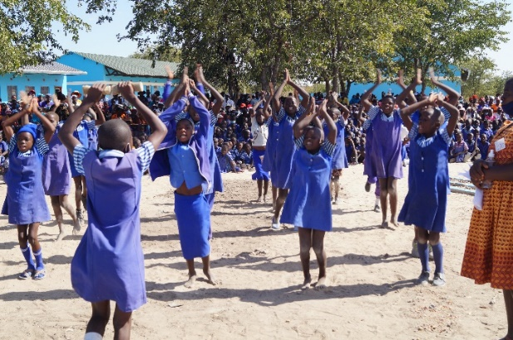

Children dancing at the ceremony

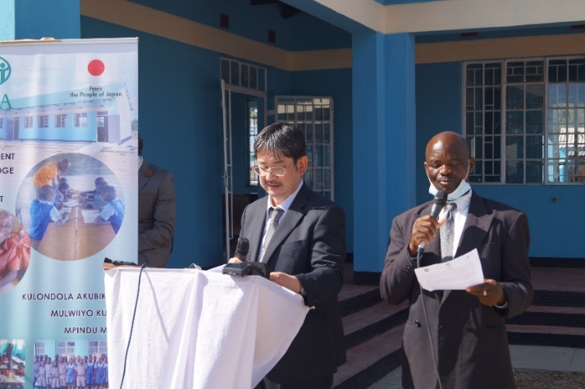

Remarks by Mr Kumagai

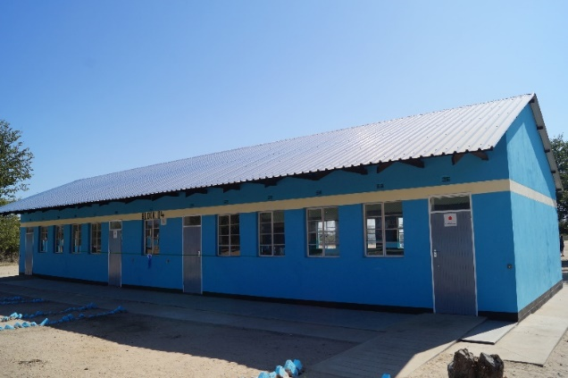

One of the new classroom blocks

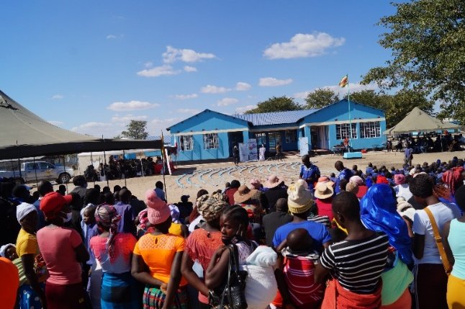

Parents and community members attending the handover ceremony