**Handover Ceremony of Grassroots Project “The Project for Provision of a Chemistry Analyser to Musiso Mission Hospital in Zaka District”**

On 14 July 2022, the *Chargé d’Affaires ad interim* at the Embassy of Japan, Mr Hiroyuki Kumagai, attended the handover ceremony of a newly provided chemistry analyser at Musiso Mission Hospital in Zaka District, Masvingo Province. The project received funding of US$27,876 through Japan’s Grant Assistance for Grassroots Human Security Projects (GGP) programme and was implemented by a local NGO, SolidarMed Zimbabwe.

Blood chemistry tests are crucial for the diagnosis and treatment of many conditions, as they provide key information on how well a person’s organs, such as the kidneys and liver, are functioning. However, not having a chemistry analyser, previously Musiso Mission Hospital was unable to provide such tests, greatly affecting health services delivery to many residents of Zaka District. Patients requiring chemistry blood analyses were referred to private laboratories in faraway Masvingo town. For most patients, these costs of the transport and tests were prohibitive, with the result that they could not access the necessary treatment.

The new chemistry analyser has allowed the hospital to provide chemistry diagnostic services, in line with the services expected of a district level hospital, as well as the necessary monitoring and care for its patients. These services are provided at an affordable cost, and the patients do not have to travel far to access them.

Speaking at the handover ceremony, Mr Kumagai thanked SolidarMed Zimbabwe for its valuable partnership and unique role in project implementation. He congratulated all the stakeholders on the new machine, and expressed his hope that it would allow many people to benefit from improved health.

Over the years, communities around Zimbabwe have benefited from the support provided by the Government of Japan under the GGP/Kusanone scheme. It provides support to improve social and economic conditions at the local level, in the fields of education, health, food and nutrition security, WASH, and support for vulnerable groups. It was launched in Zimbabwe in 1989, and 146 projects have been implemented so far throughout the country with a total of over US$14 million.

(See photos below)

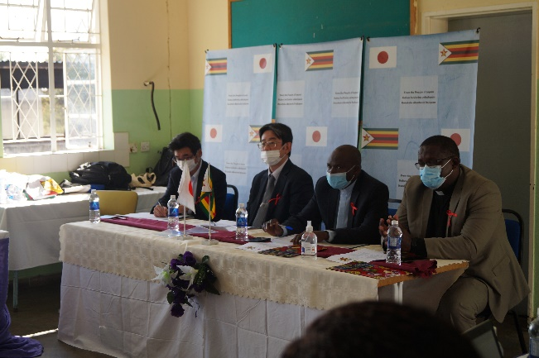

Handover Ceremony

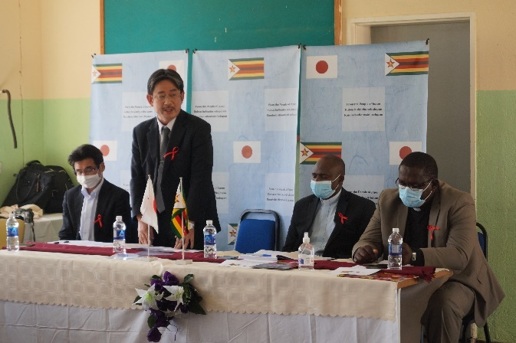

Speech by Mr Kumagai

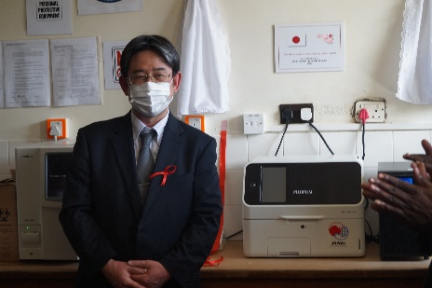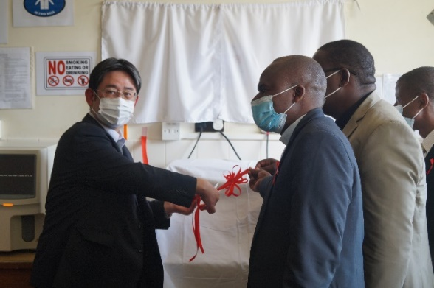

Chemistry Analyser manufactured by FujiFilm

Ribbon-cutting Ceremony

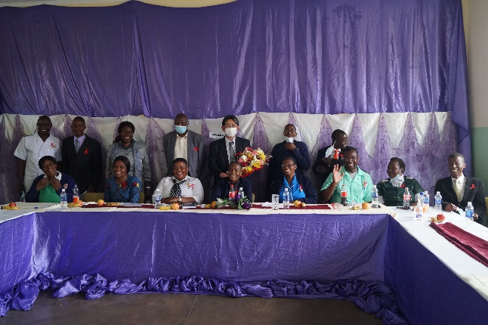

Medical Staff at Musiso Mission Hospital