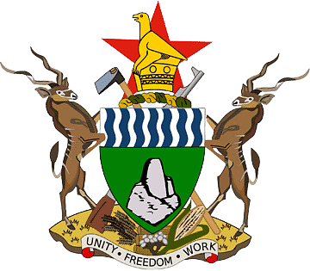**JOINT NEWS RELEASE**

22 August 2024

**JAPAN PROVIDES ADDITIONAL FOOD ASSISTANCE TO ZIMBABWE**

**HARARE** – The United Nations World Food Programme (WFP) today welcomed a contribution of US$ 1.4 million (JPY 200,000,000) from the Government of Japan. This funding will allow WFP to support approximately 26,000 people affected by the ongoing El Niño-induced drought in Zimbabwe.

Over 5.9 million people in rural parts of Zimbabwe are at risk of food insecurity between January and March 2025, the peak of the lean season, the period between planting and harvest.

“The Government of Japan and the Embassy of Japan in Zimbabwe are very concerned about the food insecurity in Zimbabwe,” said H.E Mr Shinichi Yamanaka, the Japanese Ambassador to Zimbabwe. “I hope that this food assistance will help these vulnerable people to overcome the current crisis. We will continue our support to allow all Zimbabweans to meet their food security needs.”

With this contribution, WFP will provide cereals, pulses, and vegetable oil to vulnerable communities in the hardest-hit areas impacted by the previous poor harvest due to the drought.

"Many families around Zimbabwe are worried about their next meal, so this timely and critical additional funding from the Government of Japan will help us reach the most food insecure people with nutritious food assistance,” saidMr Billy Mwiinga, WFP Zimbabwe Deputy Country Director. “We are grateful for Japan's unwavering partnership in our mission to end hunger and contribute to building resilience."

Through the Lean Season Assistance, WFP supports the Government of Zimbabwe's Food Deficit Mitigation Strategy, which protects the most vulnerable individuals from worsening food insecurity.

"The declaration of a state of disaster by His Excellency, President Emmerson Mnangagwa, underscores the severity of the drought situation in Zimbabwe,” said Hon July Moyo, Minister of Public Service, Labour, and Social Welfare. “We deeply appreciate the support from Japan and the collaborative efforts with WFP to ensure that no one is left behind during these difficult times."

The Government of Japan's continued support highlights the strong and enduring partnership between Japan, WFP, and the Government of Zimbabwe. Over the past five years, Japan has provided food assistance through WFP amounting to US$10 million, supporting about 190,000 people, including during the COVID-19 emergency.

# # #

The United Nations World Food Programme is the world’s largest humanitarian organisation, saving lives in emergencies and using food assistance to build a pathway to peace, stability and prosperity for people recovering from conflict, disasters, and the impact of climate change.

Follow us on X, formerly Twitter, @WFP_Zimbabwe, @WFP_SouthernAfrica

**For more information, please contact (email address:** [**christopher.charamba@wfp.org**](mailto:christopher.charamba@wfp.org)**):**

Christopher Charamba, WFP/ Harare, Mob. +263 784 166 251

Ifeoma Madueke-Garba, WFP/ Harare, Mob. +263 772 592 894